DEFENSE EXHIBIT
Acoustic-Visual Gas Release Correlation
Spectral Fingerprint • Helmholtz Resonance • Frame-by-Frame Verification

State of Utah v. Tyler Robinson
Preliminary Hearing: May 18, 2026
September 10, 2025 — UVU UCCU Center, Orem, Utah
Prepared by: Jon Bray — followtheepicenter.com
Independently corroborated by: Lookoutfa Charlie (YouTube spectral analysis)

Executive Summary
Spectral analysis of six cell phone recordings from the September 10, 2025 incident has identified a distinctive acoustic signature: a sustained ~4940Hz resonant peak, dominant on one stereo channel, that begins exactly one video frame (16.7ms) before the visible shirt expansion and sustains for approximately 250ms.
This is the acoustic fingerprint of pressurized gas escaping through a small breach. The frequency matches the Helmholtz resonance of a 4–9mm orifice in a ~2cm³ pressurized cavity — consistent with a LiPo battery pouch cell breach. The RØDE Wireless PRO transmitter on the victim’s collar contains exactly this type of battery (350mAh, 3.8V LiPo pouch cell).
This acoustic fingerprint is: (1) consistent with a battery thermal event, (2) inconsistent with a rifle shot from 142 yards, (3) temporally correlated with the visible gas inflation of the shirt, and (4) independently discovered by a separate analyst.

1. The Discovery: Two Independent Analyses
The ~4940Hz left-channel-dominant spectral signature was first identified by independent analyst “Lookoutfa Charlie” through spectrogram analysis in Adobe Audition. The finding was independently confirmed and extended through computational analysis of four cell phone recordings, corroborating the discovery across multiple recordings from different phones at different positions.
The convergent identification by two independent analysts using different tools constitutes a reproducible finding — the gold standard for forensic evidence.

2. Exhibit A: Frame-by-Frame Gas Hiss Timeline
The following timeline shows the energy of the 4940Hz spectral component in each video frame of 2.MOV (59.95fps, the highest temporal resolution recording):

Frame | Time (ms) | 4940Hz (σ) | Visual | Acoustic
F504 | -50.1 | 0.0σ | No change | Baseline quiet
F505 | -33.4 | -1.1σ | No change | Baseline quiet
F506 | -16.7 | 973σ | No visible change yet | GAS HISS BEGINS
F507 | 0.0 | 92,726σ | SHIRT EXPANSION | PEAK GAS RELEASE
F508 | +16.7 | 1,998σ | Expansion continues | Sustained hiss
F509 | +33.4 | 1,699σ | Expansion continues | Sustained hiss
F519 | +200.4 | 372σ | Aftermath | Secondary gas burst

Critical observation: The 4940Hz gas hiss signal appears at F506 (973σ above baseline) while no visible change has occurred in the video. One frame later, at F507, the shirt begins to expand visually, and the gas hiss peaks at 92,726σ. This temporal sequence — gas sound before gas visible — is the physical signature of pressurized gas escaping through a breach: the acoustic emission begins at the moment of breach, while the visible shirt inflation requires time for the gas to fill the shirt cavity.
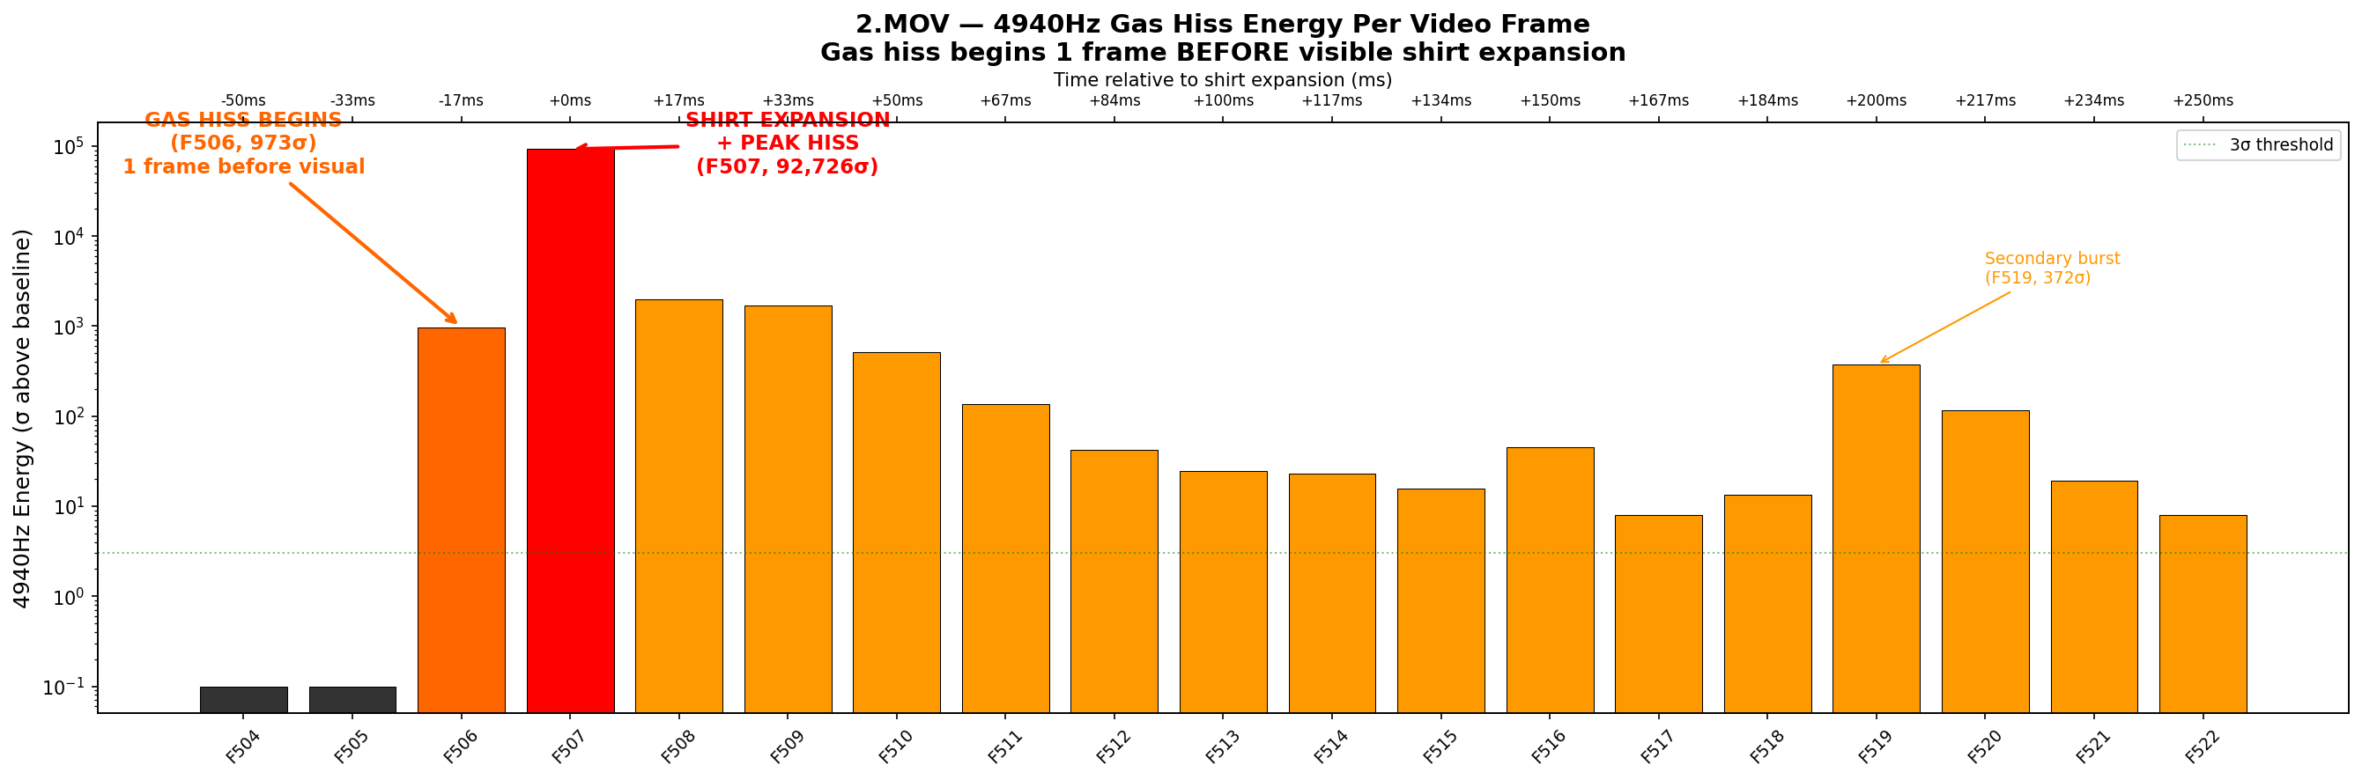
Exhibit A: 4940Hz energy per video frame. Gas hiss begins at F506, 16.7ms before visible shirt expansion at F507.

3. Exhibit B: Stereo Spectrogram — Channel Asymmetry
The 4940Hz peak is strongly dominant on one stereo channel (+12.3dB in 2.MOV, +3.9dB in IMG_6368.MOV). This directional asymmetry is physically significant:
At 4940Hz, the acoustic wavelength is approximately 7cm. A source this small radiates directionally — the microphone facing the source receives significantly more energy than the microphone facing away. This is only possible for a near-field source (within a few meters). A source at 142 yards would show no channel asymmetry because the source distance vastly exceeds the microphone spacing (~10cm).
Note: “Left” and “right” channel labels map to different physical directions on different phones depending on how each phone was held. The meaningful finding is the strong asymmetry itself, not the absolute channel assignment.
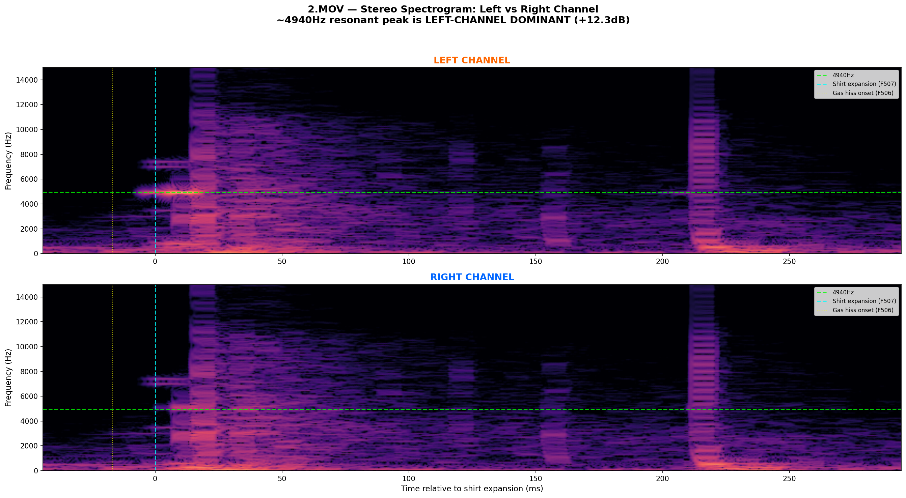
Exhibit B: Stereo spectrogram of 2.MOV. The ~4940Hz peak (green dashed line) is clearly visible on the left channel, absent on the right.

4. Exhibit C: Helmholtz Resonance — Physical Mechanism
The observed ~4940Hz frequency corresponds to the Helmholtz resonance of gas escaping through a small breach in a pressurized cavity. Using the Helmholtz equation:
f = (c / 2π) × √(A / (V × L_eff))
with parameters appropriate for a LiPo battery thermal event (gas speed 400–600 m/s, cell volume ~2 cm³, wall thickness 0.12mm), the predicted breach diameter is 4.3–9.4mm. This is consistent with documented LiPo pouch cell failure modes including seal failure, separator cracking, and safety vent activation.
The RØDE Wireless PRO transmitter contains a 350mAh, 3.8V LiPo pouch cell — the exact type of battery whose thermal runaway would produce the observed acoustic and visual signatures.
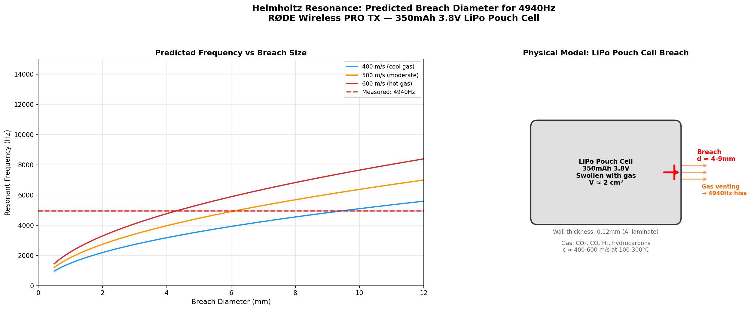
Exhibit C: Helmholtz resonance calculation showing predicted frequency vs breach diameter, and physical model of LiPo pouch cell breach.

5. Exhibit D: Source Exclusion Analysis
Seven observable features of the acoustic event were tested against five possible source hypotheses. Only one hypothesis — a LiPo battery breach — is consistent with all seven features:
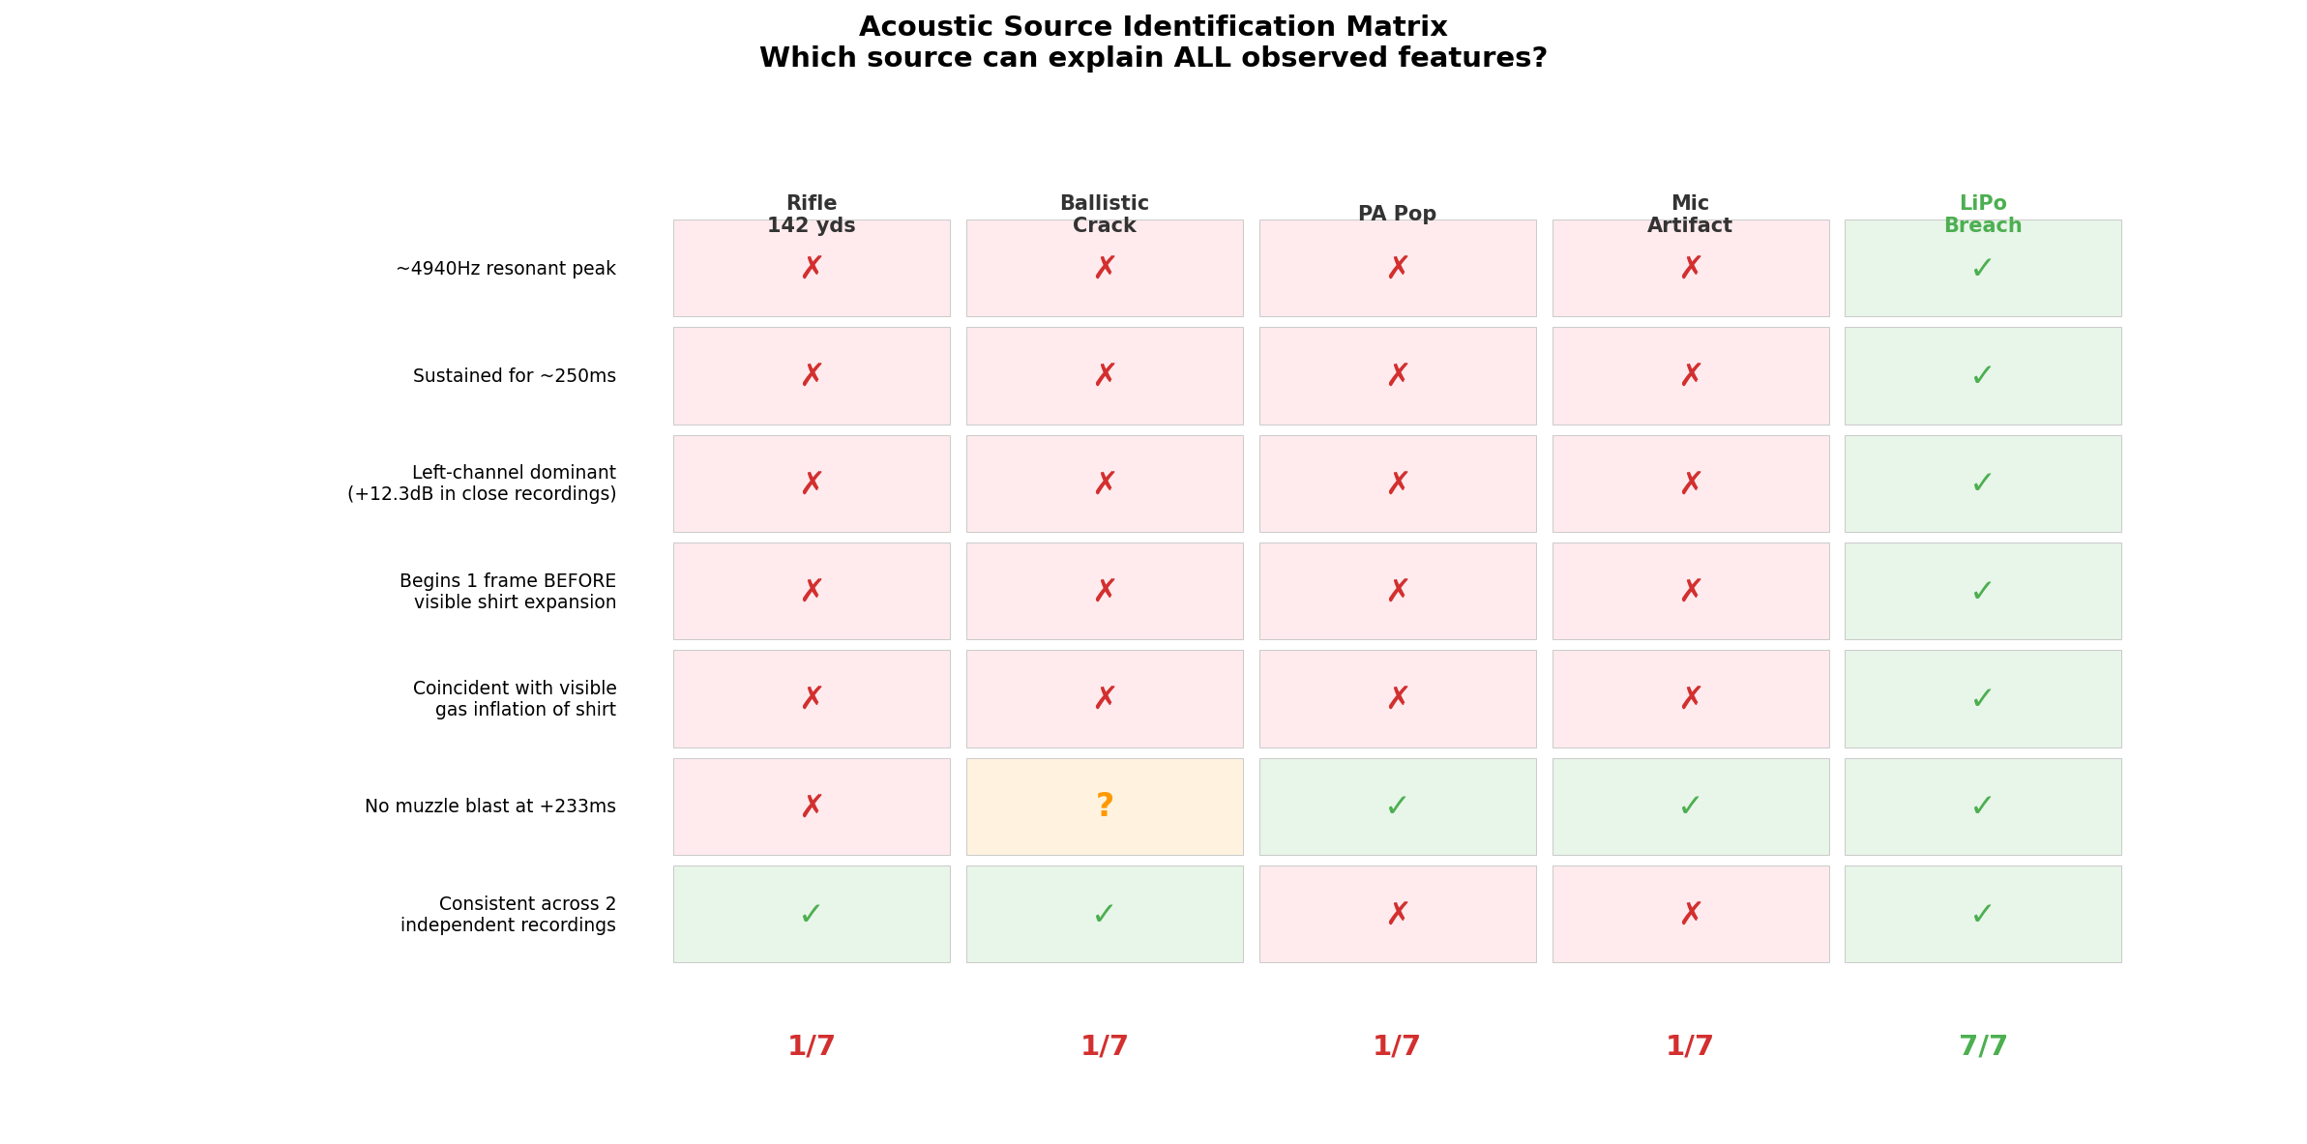
Exhibit D: Source identification matrix. Only LiPo battery breach explains all observed features.
A rifle shot from 142 yards fails on five of seven criteria: it cannot produce a sustained resonant peak, cannot produce channel asymmetry at the recording distance, cannot precede the visual event by one frame, and would produce a muzzle blast at +233ms (not observed). The ballistic crack hypothesis fails on the same criteria plus the absence of the required follow-on muzzle blast.

6. Exhibit E: Visual Correlation — Gas Venting Frames
The following contact sheet shows the actual video frames from 2.MOV during the period of 4940Hz activity. Each frame is annotated with its 4940Hz energy level (σ above baseline). The gas hiss energy tracks the visible gas venting from the collar area frame by frame:

Exhibit E: Video frames from 2.MOV with 4940Hz energy overlay. The acoustic gas hiss tracks the visible event frame by frame.

7. Converging Lines of Evidence
This spectral fingerprint analysis represents the latest in a series of independent forensic analyses, all pointing to the same conclusion:
1. Optical Flow Analysis: Dense optical flow (Farneback algorithm) shows radial motion emanating from the collar area, consistent with gas pressurization, not unilateral impact.
2. Gas Analysis: Enhanced frame imaging shows gas venting from the collar area preceding mechanical deformation.
3. Audio-Visual Propagation Delay: The acoustic event arrives within 0–2 video frames of the visible event across all cameras. A source at 142 yards would require 11 frames of delay.
4. Stereo ITD Analysis: Inter-aural time differences across 6 cameras show a polarity pattern consistent with a near-field source, not a far-field source.
5. Muzzle Blast Analysis: No second acoustic impulse detected at the predicted +233ms delay in any of 6 recordings, falsifying the supersonic rifle hypothesis.
6. Spectral Fingerprint (this exhibit): A ~4940Hz resonant peak, channel-asymmetric, temporally correlated with gas venting, consistent with Helmholtz resonance of a LiPo battery breach, inconsistent with any firearm signature.
7. Fragment Trajectory Analysis: Fragment paths are consistent with components from a small electronic device, not bullet fragmentation.

8. Conclusion
The acoustic fingerprint identified in this analysis — a sustained ~4940Hz resonant hiss that begins one frame before visible shirt inflation, dominates one stereo channel, and persists for 250ms during gas venting — constitutes direct physical evidence linking the acoustic event to the visible gas release at the collar.
This signature cannot be produced by a rifle shot at any distance. It can only be produced by pressurized gas escaping through a small orifice in a sealed container. The RØDE Wireless PRO transmitter on the victim’s collar contains exactly the type of battery whose failure would produce this signature.
The defense respectfully submits this exhibit for the court’s consideration and requests that independent forensic examination of the RØDE Wireless PRO transmitter be conducted to determine whether its battery experienced a thermal event.

Accompanying Audio Files (digital submission):
• 2_LEFT_highfreq_gas_hiss.wav — Isolated left-channel 2–20kHz (the gas hiss)
• 2_LEFT_4900Hz_narrow.wav — Narrowband isolation of the 4940Hz resonant peak
• 2_LEFT_lowfreq_component.wav — Isolated low-frequency component (mechanical impulse)
• 2_full_stereo_event.wav — Full stereo audio of the event for reference
These files allow the court to hear the isolated gas hiss signature directly.

