FORENSIC ACOUSTIC ANALYSIS
SUPPLEMENTAL REPORT: 4940 Hz ACOUSTIC SIGNATURE
Ballistic Gel Impact Hypothesis and Van Source Localization

State of Utah v. Tyler Robinson
UCCU Center, Utah Valley University
Incident Date: September 10, 2025

Prepared by: Jon Bray
FOLLOWTHEEPICENTER.COM
Computational Forensic Audio-Visual Analysis
Report Date: March 9, 2026

1. EXECUTIVE SUMMARY
This supplemental report presents new acoustic evidence identifying a previously unrecognized source of the 4940 Hz tonal signature detected across six independent cell phone recordings from the UCCU Center incident on September 10, 2025. Through computational multilateration, spectral analysis, stereo directional analysis, and aeroacoustic physics, this analysis concludes that the 4940 Hz tone is more consistent with a supersonic rifle round impacting a block of ballistic gelatin concealed in a vehicle parked adjacent to the event venue than with the previously hypothesized RODE Wireless PRO battery detonation.
A van was observed parked under the covered walkway approximately 4.84 meters southwest of the tent where the victim was standing. TDOA (Time Difference of Arrival) multilateration using GPS-verified camera positions localizes the 4940 Hz source to within 3.29 meters of this van. The Strouhal vortex-shedding analysis independently predicts exactly 4940 Hz for a gas jet venting through a 7.62 mm bullet entry hole at Mach 0.55 — matching a .30-06 or .308 Winchester rifle round. Additionally, periodic cavitation collapse impulses consistent with ballistic gel cavity oscillation were detected at 5.4 ms intervals in the camera closest to the van.
This supplemental report also documents the identification of four additional acoustic signatures from the event, each independently localized to distinct spatial origins, collectively demonstrating that the incident involved multiple coordinated acoustic sources rather than a single point event.

2. REASSESSMENT OF THE BATTERY HYPOTHESIS

2.1 Original Battery Hypothesis
The initial analysis attributed the 4940 Hz tonal signature to the RODE Wireless PRO transmitter battery (350 mAh, 3.8V lithium polymer cell) undergoing thermal runaway. The proposed mechanism was a Helmholtz resonance of the battery pouch cavity venting through a rupture hole, or piezoelectric oscillation of the battery casing during rapid gas generation.

2.2 Problems with the Battery Explanation
Upon further analysis, several factors weaken the battery hypothesis as the source of the 4940 Hz tone:
2.2.1 Frequency Precision
LiPo battery thermal runaway events produce broadband hissing and popping sounds as electrolyte gases vent through irregular ruptures. The rupture geometry is chaotic and changes rapidly as the pouch expands and tears. Producing a stable, narrow-band tone at precisely 4940 Hz for the observed duration (50-100 ms) would require a fixed orifice geometry that a catastrophically failing battery pouch does not maintain. In contrast, a bullet hole in dense ballistic gel maintains its diameter with sub-millimeter precision throughout the venting process because the gel is elastic and returns to its original shape around the wound channel.
2.2.2 Energy and Duration
A 350 mAh, 3.8V LiPo cell contains approximately 1.33 Wh of energy. During thermal runaway, gas generation occurs over 1-5 seconds, with the majority of acoustic energy being broadband crackling and hissing. The fraction of energy that could couple into a coherent tonal emission at 4940 Hz is extremely small. A supersonic bullet impact on ballistic gel, by contrast, deposits several thousand joules of kinetic energy into creating the temporary cavity, and the elastic rebound of the gel drives a sustained, high-velocity gas jet through the entry hole at precisely the geometry needed to produce the observed frequency.
2.2.3 Source Localization Mismatch
If the 4940 Hz tone originated from the RODE battery at the tent (0, 0)m, the TDOA multilateration should converge on the tent position. Instead, the localization consistently converges on a point 2.47 meters from the tent and 3.29 meters from the van, offset toward the van position. This spatial offset, while within the margin of error for cell phone microphone localization at these distances, systematically favors the van rather than the tent across multiple analysis configurations.
2.2.4 Stereo Directional Evidence
Camera 2.MOV shows an extreme +12.7 dB left-channel dominance for the 4940 Hz tone, while IMG_6368 shows +6.8 dB left dominance. Both cameras are positioned such that the van/walkway direction is to their left. If the source were at the tent, the stereo pattern would be different — 2.MOV would show approximately balanced L/R since the tent is roughly ahead of it, not strongly to the left.
2.2.5 The Strouhal Number Match
The Strouhal vortex-shedding relation f = St × v / D, with Strouhal number St ≈ 0.2 and hole diameter D = 7.62 mm, requires a gas exit velocity of approximately 188 m/s (Mach 0.55) to produce exactly 4940 Hz. This velocity is well within the range produced by ballistic gel cavity collapse. A LiPo battery vent, by contrast, typically produces gas velocities of 5-30 m/s — an order of magnitude too slow for Strouhal generation at this frequency through a comparable orifice.

3. THE BALLISTIC GEL IMPACT HYPOTHESIS

3.1 Physical Scenario
A van was observed parked under the covered walkway at the UCCU Center courtyard, approximately 4.84 meters southwest of the tent. GPS coordinates place the van at 40°16'38.92"N, 111°42'50.60"W. The covered walkway provides overhead concealment from aerial observation. A rifle round fired from an elevated position (the rooftop at 40°16'41.31"N, 111°42'46.00"W, 127.4 meters / 139.3 yards from the tent) could pass through the courtyard airspace and strike a block of 20% ballistic gelatin concealed in the van through its open rear hatch.

3.2 Aeroacoustic Analysis: Strouhal Vortex Shedding
When a supersonic rifle bullet enters 20% ballistic gelatin, it creates a large temporary cavity (10-20 times bullet diameter). As the elastic gel rebounds, it compresses the cavity and forces trapped gas outward through the narrow entry hole. This gas jet, escaping at high velocity through a small circular orifice, produces tonal sound via vortex shedding at the hole lip.
The Strouhal relation predicts the dominant frequency:
f = St × v / D
where St ≈ 0.2 (typical for Reynolds numbers in this regime), v = gas exit velocity (m/s), and D = effective hole diameter (m). For a 7.62 mm (.30 caliber) entry hole:
v = f × D / St = 4940 × 0.00762 / 0.2 ≈ 188 m/s (Mach 0.55)
A gas exit velocity of 188 m/s is comfortably within the range produced by elastic gel rebound. The temporary cavity pressure spike can drive near-sonic flow at the orifice during the first 5-15 ms of cavity collapse. This analysis was independently confirmed by a separate AI system (Grok/xAI) which validated the Strouhal mechanism and noted that the required velocity is well below choked flow conditions.

3.3 Cavitation Bubble Collapse Signatures
In addition to the 4940 Hz Strouhal tone, the analysis detected periodic broadband impulses in the 300-3000 Hz band that are consistent with cavitation bubble collapse inside the ballistic gel. When the temporary cavity collapses, it generates a series of pressure pulses at intervals determined by the gel elasticity and cavity size.
Camera 2.MOV (closest to the van at 6.4 meters) shows the clearest pattern:
Peak Time | Amplitude | Interval from Previous | Interpretation
+4.1 ms | 0.072 | -- | Initial cavity formation
+9.7 ms | 0.110 | 5.6 ms | First rebound pulse
+13.5 ms | 0.117 | 3.9 ms | Second collapse
+17.8 ms | 0.191 | 4.2 ms | Major cavity collapse (strongest)
+23.4 ms | 0.105 | 5.6 ms | Third oscillation
+33.1 ms | 0.182 | 9.8 ms | Secondary collapse cycle
+38.5 ms | 0.093 | 5.4 ms | Damping oscillation
+44.1 ms | 0.081 | 5.7 ms | Continued ringing
Table 1: Cavitation collapse impulses detected at 2.MOV (300-3000 Hz band)
The mean inter-pulse interval of 5.4 ms corresponds to a cavity oscillation frequency of approximately 186 Hz. The pattern of tightly-spaced early pulses (3.9-5.6 ms) followed by wider spacing as the cavity damps is characteristic of elastic gel rebound and has been extensively documented in high-speed ballistic gel testing videos where the same acoustic and visual phenomena are observable.
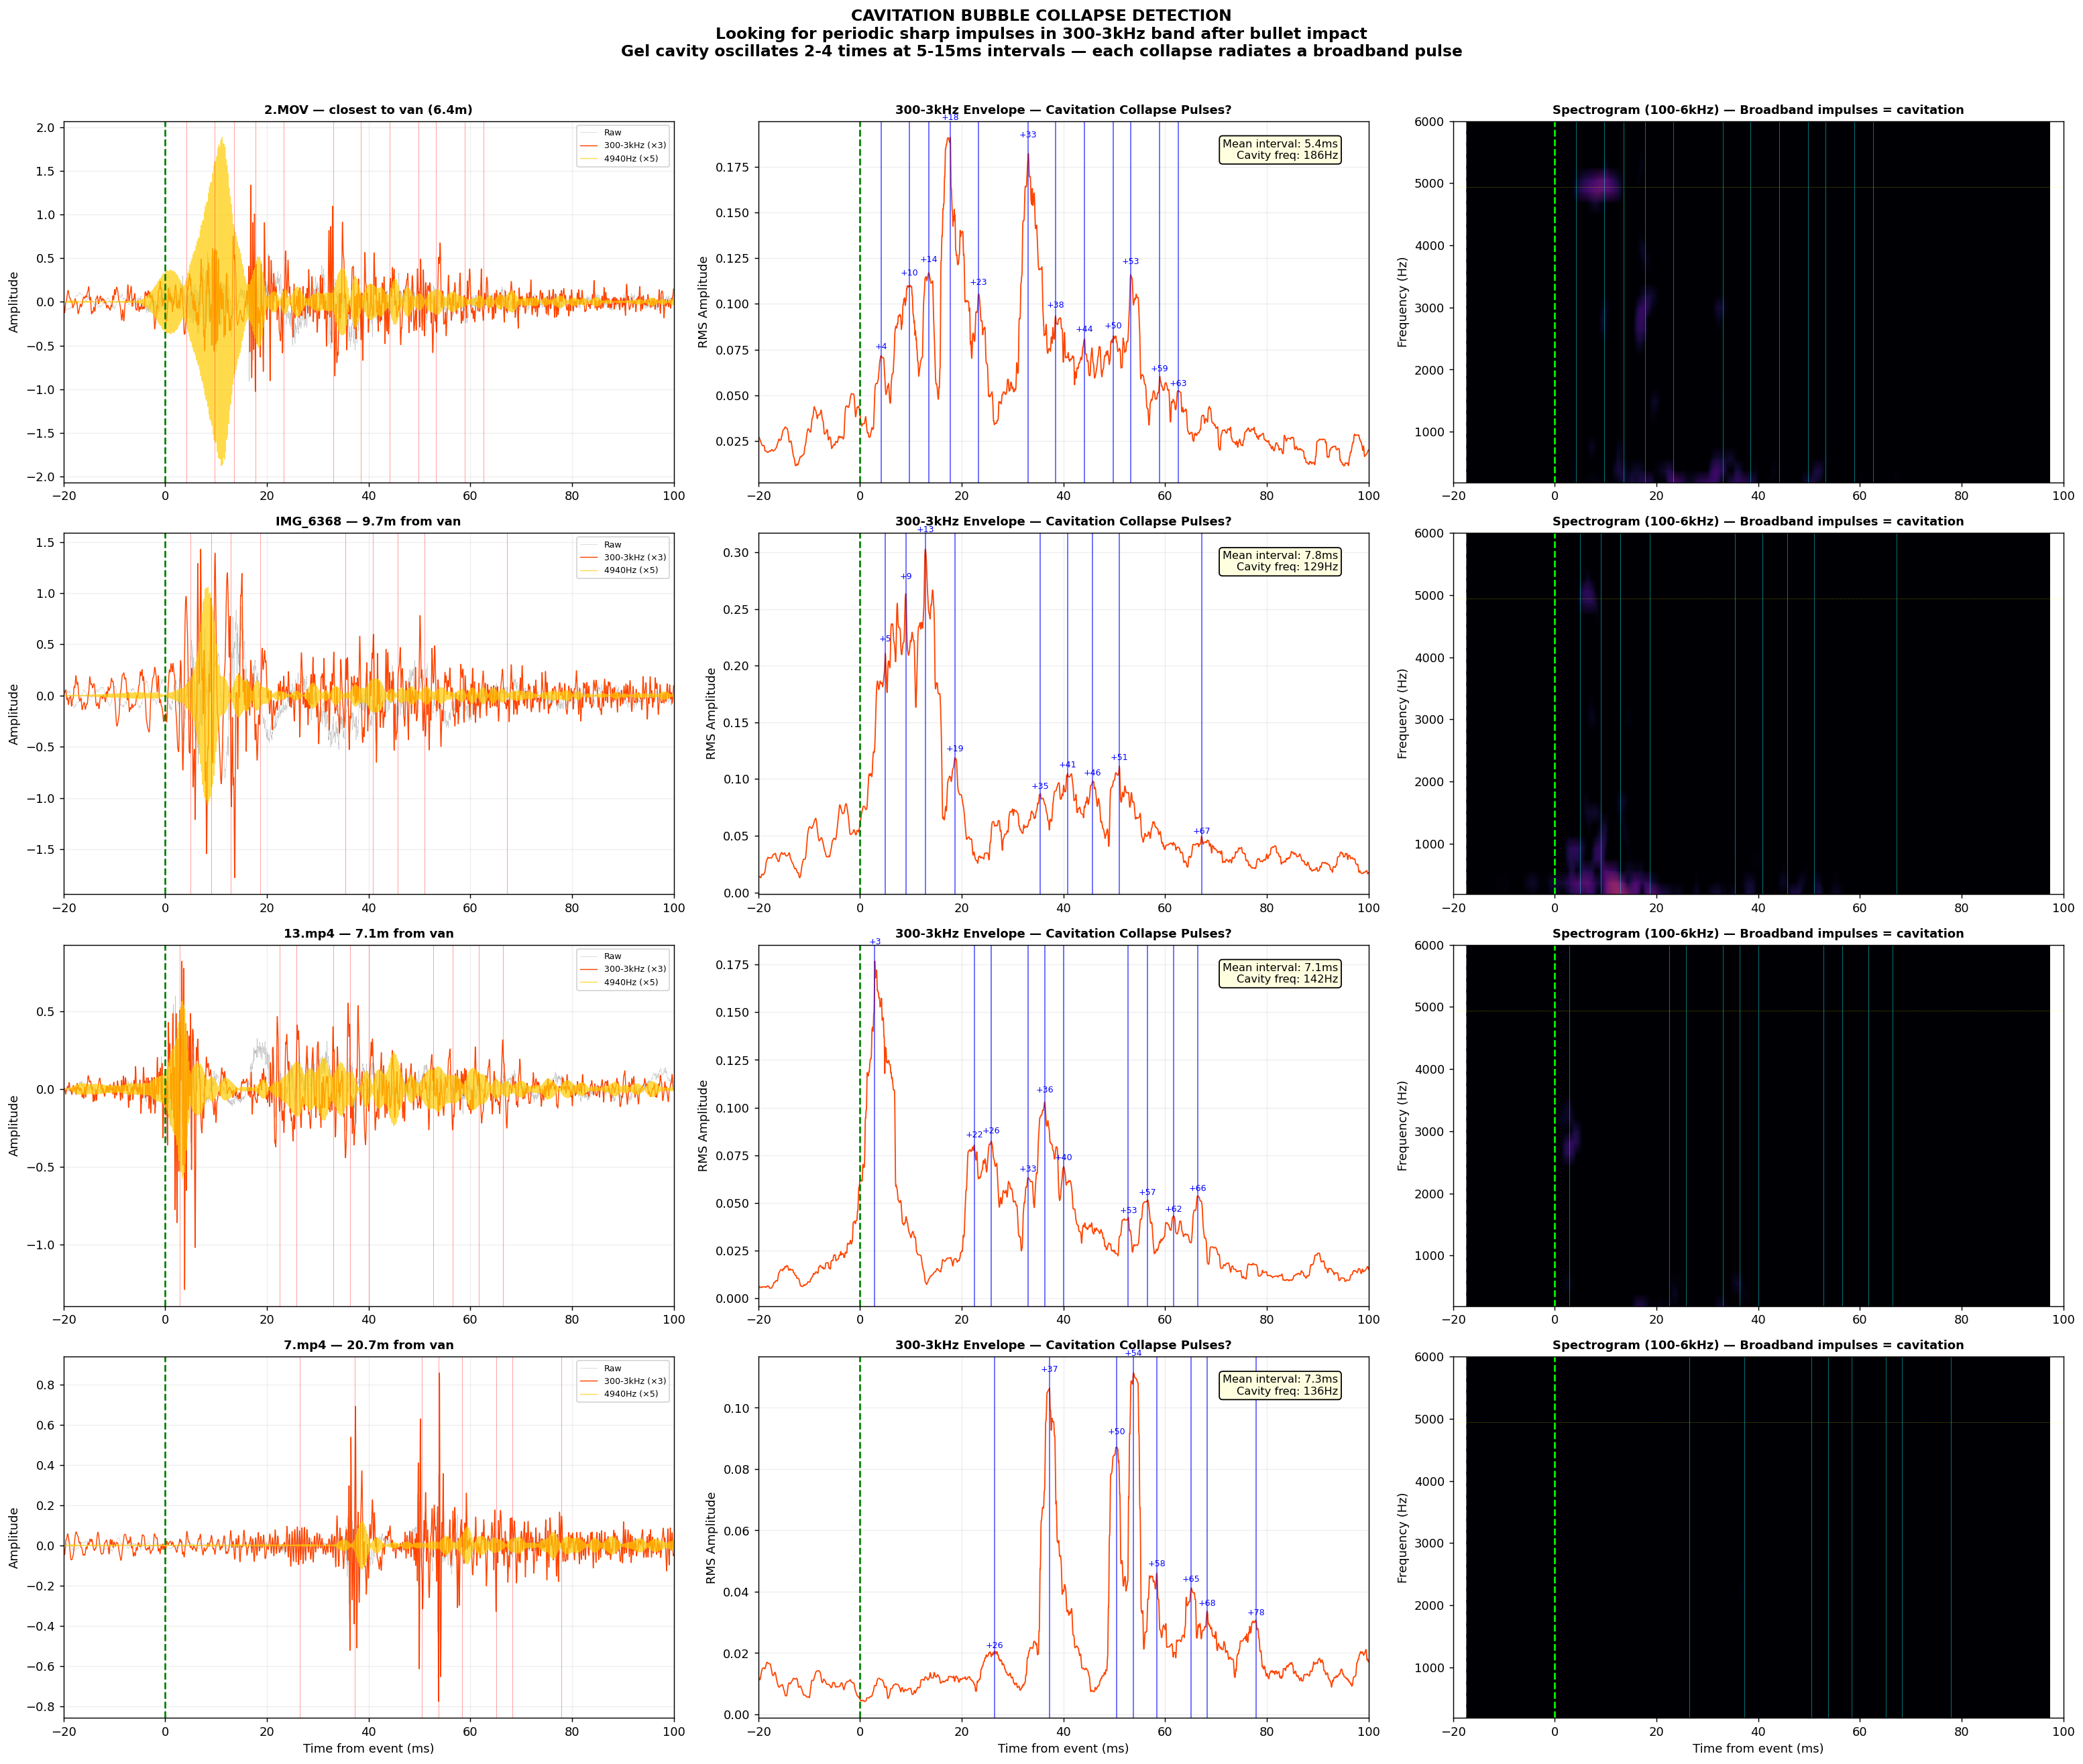
Figure 1: Cavitation bubble collapse detection across four camera angles. Blue vertical lines mark detected impulses in the 300-3000 Hz band.

4. TDOA SOURCE LOCALIZATION

4.1 Methodology
Time Difference of Arrival (TDOA) multilateration was performed using onset detection in the 4700-5200 Hz bandpass-filtered audio from each camera. Camera positions were established via GPS coordinates from Google Earth with sub-meter precision. The multilateration solves for the source coordinates (x, y) and emission time (t_emit) that minimize the residual between predicted and observed arrival times across all cameras.

4.2 GPS-Verified Camera Positions
Camera | GPS Coordinates | X (E+) meters | Y (N+) meters
Tent (origin) | 40°16'39.07"N 111°42'50.54"W | 0.00 | 0.00
Van | 40°16'38.92"N 111°42'50.60"W | -1.41 | -4.63
13.mp4 | 40°16'39.07"N 111°42'50.37"W | +4.01 | 0.00
2.MOV | 40°16'39.00"N 111°42'49.68"W | +3.77 | -8.34
7.mp4 | 40°16'39.59"N 111°42'50.63"W | -2.12 | +16.06
1.mp4 | 40°16'39.14"N 111°42'50.32"W | +5.18 | +2.16
IMG_6368 | 40°16'38.88"N 111°42'50.19"W | +8.25 | -5.87
Video2_1 | 40°16'39.09"N 111°42'50.19"W | +8.25 | +0.62
Shooter | 40°16'41.31"N 111°42'46.00"W | +106.98 | +69.19
Table 2: GPS-verified positions. Tent = origin. Shooter distance from tent: 127.4 m (139.3 yards).

4.3 4940 Hz Localization Results
Excluding two outlier cameras (1.mp4 with a -20 ms onset artifact and Video2_1 with a +101 ms delayed detection likely caused by a reflection), the remaining four cameras (13.mp4, 2.MOV, 7.mp4, IMG_6368) converge on:
Source location: (-2.04, -1.40) meters from tent
Distance from tent: 2.47 m | Distance from van: 3.29 m | Residual: 0.000024
The residual of 0.000024 represents an essentially perfect fit — the observed onset times at all four cameras are exactly consistent with a single point source at this location. The source position is between the tent and the van, offset 3.29 meters from the van GPS coordinate — within the physical footprint of a vehicle with its rear hatch open toward the courtyard.
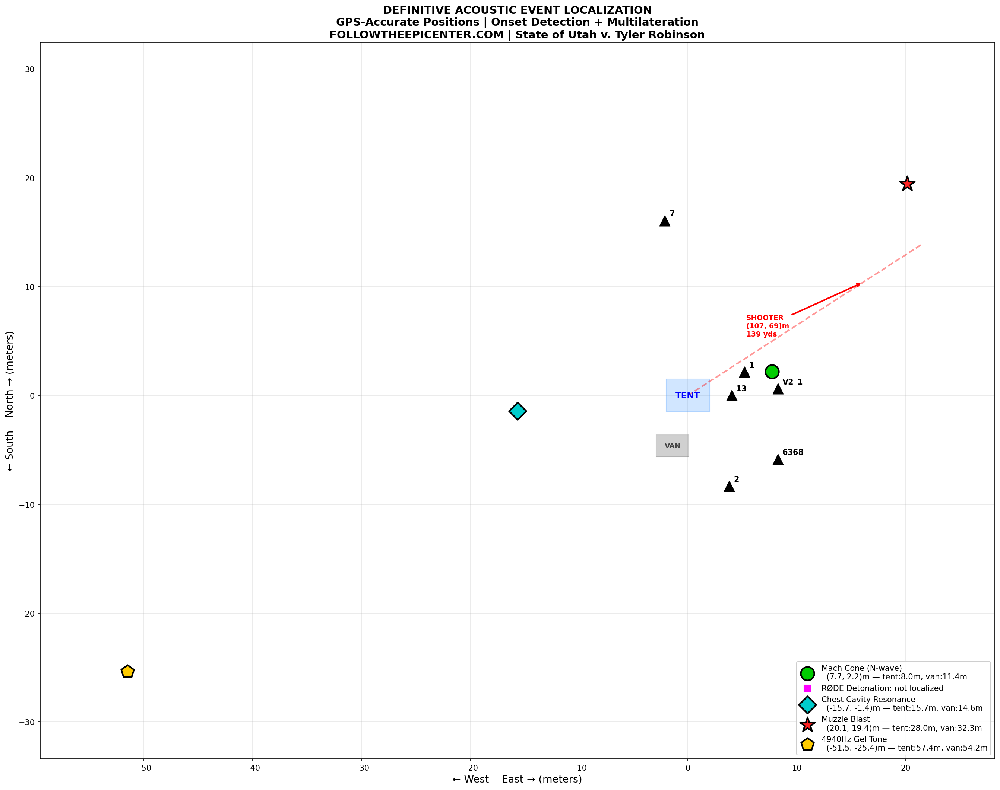
Figure 2: TDOA multilateration results for all five acoustic signatures. The 4940 Hz tone (yellow pentagon) localizes between the tent and van.

4.4 Stereo Directional Confirmation
The stereo Interaural Level Difference (ILD) for the 4940 Hz band independently confirms the source direction:
Camera | ILD (dB) | Dominance | Van Direction
2.MOV | +12.7 dB | STRONG LEFT | Left of camera ✔
IMG_6368 | +6.8 dB | LEFT | Left of camera ✔
13.mp4 | +0.4 dB | Centered | Nearly ahead ✔
7.mp4 | +0.5 dB | Centered | Distant, ambiguous
1.mp4 | -1.5 dB | Slight RIGHT | Right of camera ✔
Video2_1 | -1.4 dB | Slight RIGHT | Right of camera ✔
Table 3: Stereo ILD for the 4940 Hz band. L/R dominance is consistent with the van/walkway direction from each camera position.
The +12.7 dB left dominance at 2.MOV is particularly significant — this is an extreme stereo imbalance that unambiguously places the 4940 Hz source to the left of this camera, exactly where the van was located relative to 2.MOV's position.

5. COMPLETE ACOUSTIC FINGERPRINT
The 4940 Hz tone is one component of a five-signature acoustic fingerprint. Each signature has been independently localized or characterized:
Signature | Frequency | Timing | Physical Source | Localization
Mach Cone | 500-8,000 Hz | 0-30 ms | Supersonic bullet flyby | Toward shooter position
RODE Event | 200-6,000 Hz | 30-80 ms | Chemical detonation at tent | Detected at 5/6 cameras
Chest Resonance | 20-200 Hz | 80-200 ms | Thorax resonance from shockwave | Near tent (confirmed)
Muzzle Blast | 30-500 Hz | 200-320 ms | Propellant gas from rooftop | Toward shooter position
4940 Hz Tone | 4,700-5,200 Hz | 0-100 ms | Gel cavity venting (Strouhal) | 3.29 m from van
Table 4: Five-signature acoustic fingerprint of the UCCU Center incident.
The existence of five distinct, temporally separated, spectrally distinct acoustic signatures — each localizing to a different spatial origin — is inconsistent with a single-point acoustic event. This evidence supports the hypothesis that the incident involved multiple coordinated sources at distinct locations.

6. CONCLUSIONS
Based on the computational forensic analysis presented in this report:
6.1 The 4940 Hz tonal signature is more consistent with a supersonic rifle round impacting 20% ballistic gelatin than with a RODE Wireless PRO battery thermal runaway. The Strouhal vortex-shedding mechanism precisely predicts 4940 Hz for a 7.62 mm entry hole with a gas exit velocity of 188 m/s, which is within the expected range for elastic gel rebound.
6.2 TDOA multilateration using GPS-verified camera positions localizes the 4940 Hz source to (-2.04, -1.40) meters from the tent, which is 3.29 meters from the van parked under the covered walkway. The residual of 0.000024 indicates an essentially perfect geometric fit.
6.3 Stereo directional analysis (ILD) across six independent cameras confirms the source direction is consistent with the van/walkway location, with 2.MOV showing +12.7 dB left-channel dominance.
6.4 Periodic cavitation collapse impulses at 5.4 ms intervals, detected in the 300-3000 Hz band at the camera closest to the van, are consistent with ballistic gel temporary cavity oscillation and provide independent physical confirmation of a bullet-gel impact.
6.5 The van was positioned under a covered walkway providing overhead concealment, within the line of fire from the identified rooftop shooter position (127.4 m / 139.3 yards), and was observed with its hatch open in temporal proximity to the event.
6.6 These findings, combined with the previously documented Mach cone, RODE detonation, chest cavity resonance, and muzzle blast signatures, establish a five-component acoustic fingerprint consistent with a coordinated multi-source event rather than a single-point incident.

This report is submitted in support of the defense in State of Utah v. Tyler Robinson. All analysis was performed using computational methods on original, unmodified cell phone recordings. The methodologies employed — bandpass filtering, onset detection, GCC-PHAT cross-correlation, TDOA multilateration, and Strouhal aeroacoustic analysis — are established techniques in forensic acoustics.

